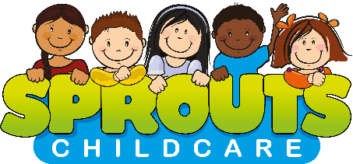

Working in Partnership with Shakespeare Junior School
Sprouts have been providing wrap around care, to schools within the local area of locks heath, since 2015. We are very excited to have expanded our portfolio into the Eastleigh area, and to be working with Shakespeare Junior School.
We opened the club in September 2021 and have built up a good working relationship with both the school and the families.
A little bit about us……



Amy
Charlotte (Charlie)

Sprouts’ founders Charlotte and Amy are qualified early years professionals who have worked in childcare for over 12 years whilst bringing up young families of their own, so share a wealth of skills and experience in the sector.
Currently working with over 900 children and their families within nine popular schools. Sprouts is dedicated to supporting schools and parents by providing specialist expertise and support in wrap around care and holiday clubs.
Sprouts operate an online booking service, to make it flexible for families to book in advance or on the day.
To register and reserve your space please book at www.sproutschildcare.co.uk.
Our Sessions
After School Club | End of School day – 5:45pm | £13.00 per child / per session
OFSTED Reg | 2653041

Find out more about us at www.sproutschildcare.co.uk.

